# **Name: Abdurrahman Qureshi**

# **Roll No: 210451**

Practical No: 23

1. Write a Program to capture an image and display it using Image View.

Activity_main.xml

<?xml version="1.0" encoding="utf-8"?>  
<RelativeLayout xmlns:android="http://schemas.android.com/apk/res/android"  
 xmlns:tools="http://schemas.android.com/tools"  
 android:layout_width="match_parent"  
 android:layout_height="match_parent"  
 tools:context=".MainActivity">  
  
 <Button  
 android:id="@+id/buttonCapture"  
 android:layout_width="wrap_content"  
 android:layout_height="wrap_content"  
 android:text="Capture Image"  
 android:layout_centerInParent="true" />  
  
 <ImageView  
 android:id="@+id/imageView"  
 android:layout_width="100dp"  
 android:layout_height="100dp"  
 android:layout_below="@id/buttonCapture"  
 android:layout_marginTop="20dp"  
 android:scaleType="fitCenter"  
 android:visibility="gone" />  
  
</RelativeLayout>

MainActivity.java

package com.example.mad_playground;  
  
import android.app.Activity;  
import android.content.Intent;  
import android.graphics.Bitmap;  
import android.os.Bundle;  
import android.provider.MediaStore;  
import android.view.View;  
import android.widget.Button;  
import android.widget.ImageView;  
  
public class MainActivity extends Activity {  
 private static final int *REQUEST_IMAGE_CAPTURE* = 1;  
 private ImageView imageView;  
  
 @Override  
 protected void onCreate(Bundle savedInstanceState) {  
 super.onCreate(savedInstanceState);  
 setContentView(R.layout.*activity_main*);  
  
 Button buttonCapture = findViewById(R.id.*buttonCapture*);  
 imageView = findViewById(R.id.*imageView*);  
  
 buttonCapture.setOnClickListener(new View.OnClickListener() {  
 @Override  
 public void onClick(View v) {  
 dispatchTakePictureIntent();  
 }  
 });  
 }  
  
 private void dispatchTakePictureIntent() {  
 Intent takePictureIntent = new Intent(MediaStore.*ACTION_IMAGE_CAPTURE*);  
 if (takePictureIntent.resolveActivity(getPackageManager()) != null) {  
 startActivityForResult(takePictureIntent, *REQUEST_IMAGE_CAPTURE*);  
 }  
 }  
  
 @Override  
 protected void onActivityResult(int requestCode, int resultCode, Intent data) {  
 super.onActivityResult(requestCode, resultCode, data);  
 if (requestCode == *REQUEST_IMAGE_CAPTURE* && resultCode == *RESULT_OK*) {  
 Bundle extras = data.getExtras();  
 Bitmap imageBitmap = (Bitmap) extras.get("data");  
 imageView.setImageBitmap(imageBitmap);  
 imageView.setVisibility(View.*VISIBLE*);  
 }  
 }  
}

OUTPUT:

 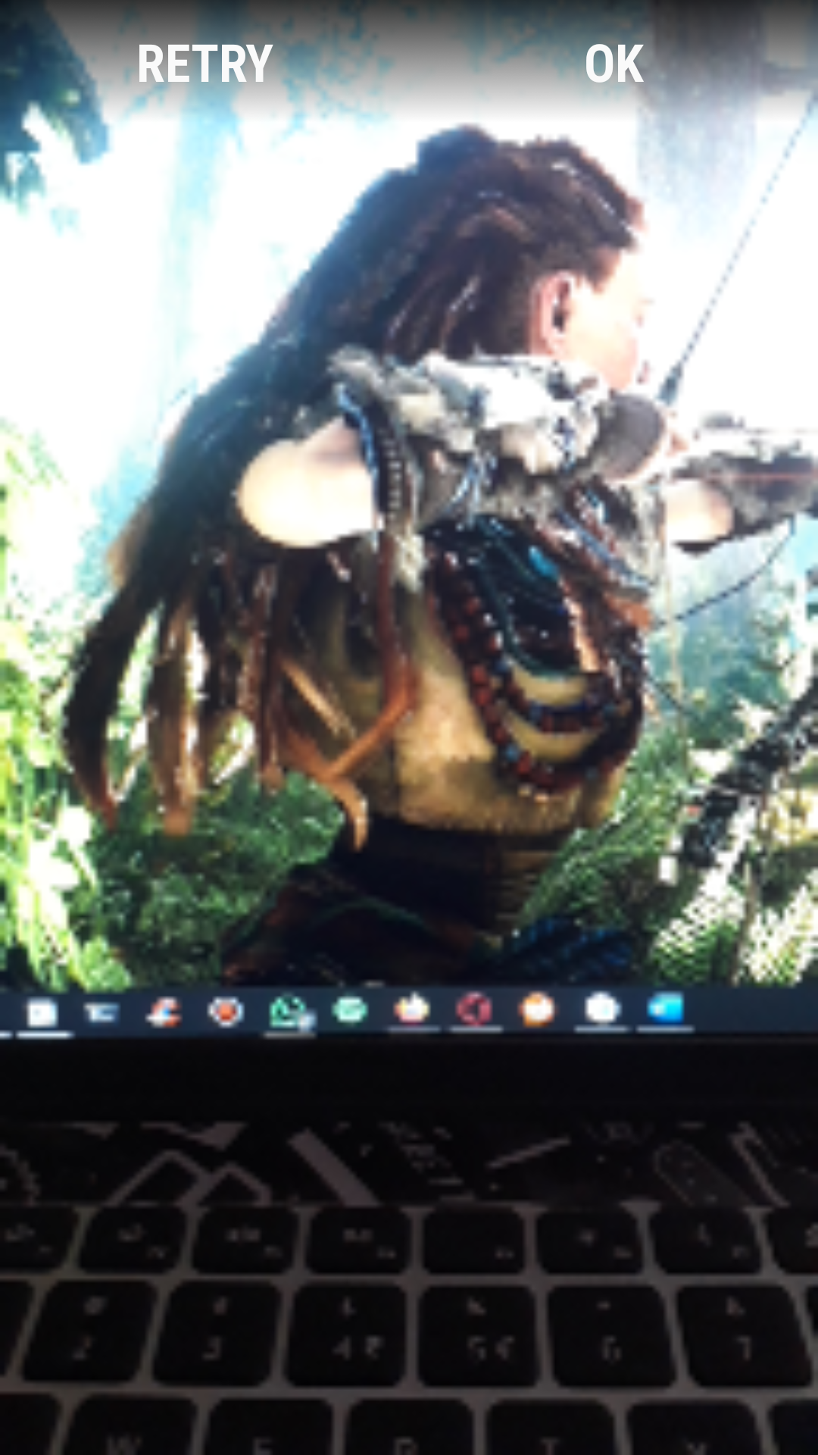 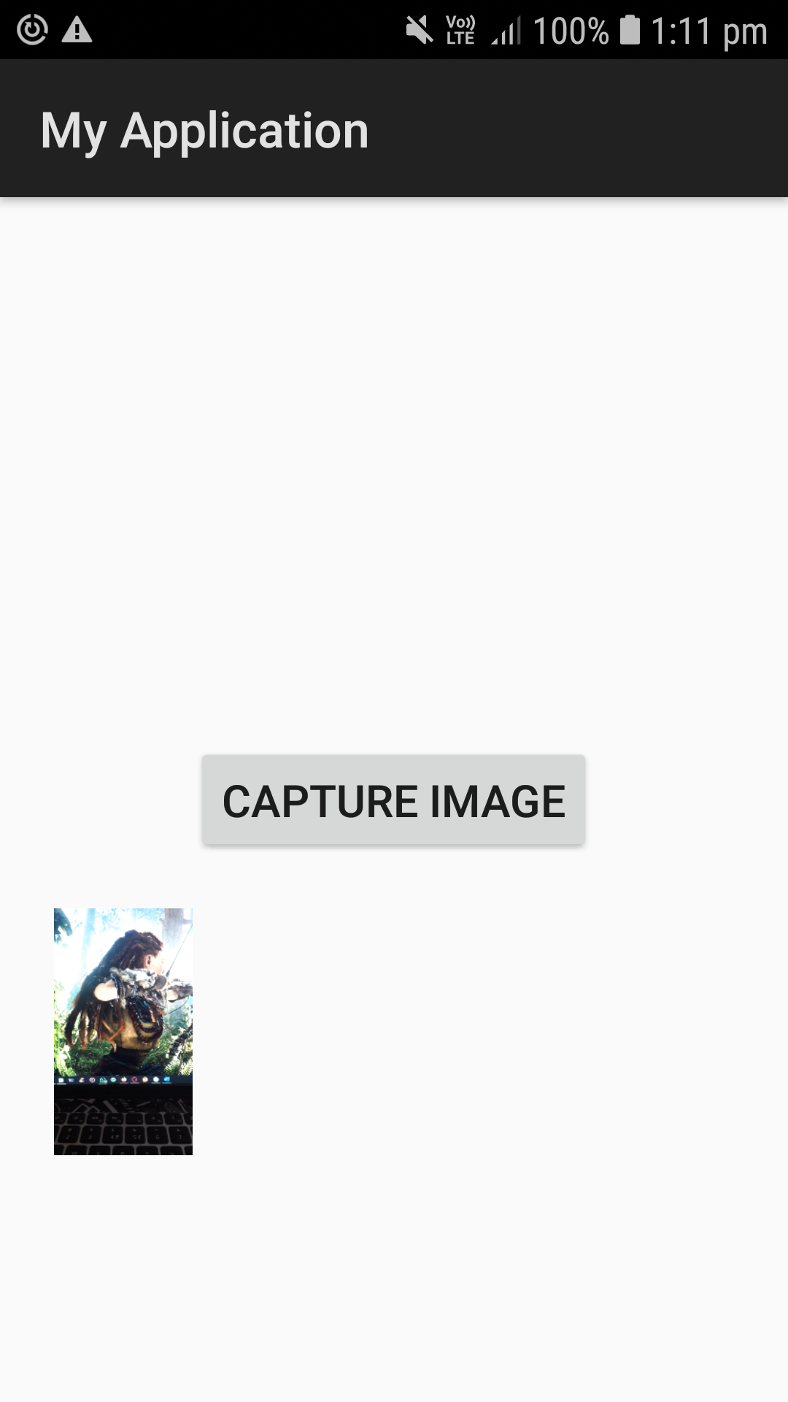

1. Write a Program to Open a new Activity and set the Text of the Text View of the main activity by the which data is entered in the Edit Text of the new Activity opened.

Activity_main.xml

package com.example.mad_playground;  
  
import android.content.Intent;  
import android.net.Uri;  
import android.os.Bundle;  
import android.util.Log;  
import android.view.View;  
import android.widget.Button;  
import android.widget.EditText;  
  
import androidx.appcompat.app.AppCompatActivity;  
  
public class MainActivity extends AppCompatActivity {  
 String LifeCycle = "My Main Activity LifeCycle";  
 @Override  
 protected void onCreate(Bundle savedInstanceState) {  
 super.onCreate(savedInstanceState);  
 setContentView(R.layout.*activity_main*);  
 Log.*d*(LifeCycle, "onCreate() ---> called");  
 EditText num = findViewById(R.id.*num*);  
 Button button = findViewById(R.id.*button*);  
 button.setOnClickListener(new View.OnClickListener() {  
 @Override  
 public void onClick(View view) {  
 Intent intent = new Intent(getApplicationContext(), second_activity.class);  
 intent.putExtra("num", Integer.*parseInt*(*num*.getText().toString()));  
 startActivity(intent);  
 }  
 });  
 }  
}

second_activity.java

package com.example.mad_playground;  
  
import androidx.appcompat.app.AppCompatActivity;  
  
import android.content.Intent;  
import android.os.Bundle;  
import android.widget.TextView;  
  
public class second_activity extends AppCompatActivity {  
  
 @Override  
 protected void onCreate(Bundle savedInstanceState) {  
 super.onCreate(savedInstanceState);  
 setContentView(R.layout.*activity_second*);  
 TextView text = findViewById(R.id.*text*);  
 Intent intent = getIntent();  
 int num = intent.getIntExtra("num", 1);  
 int fact = 1;  
 for(int i = 1; i<=num; i++) {  
 fact = fact * i;  
 }  
 text.setText("Factorial of "+ num +" is "+ fact);  
 }  
}

OUTPUT:

